Hood River Spring Chinook and Steelhead Forecasting Models

Mark Roes, Mount Hood Environmental. [mark.roes@mthoodenvironmental.com](mailto:mark.roes@mthoodenvironmental.com)

Prepared for Confederated Tribes of Warm Springs

2023-03-23

## Forecasts

Below are the forecasts for 2023

| **Run** | **Prediction** | **90% PI, lower** | **90% PI, upper** |
| --- | --- | --- | --- |
| NOR winter steelhead | 450 | 88 | 808 |
| HOR winter steelhead | 606 | 0 | 1,464 |
| NOR summer steelhead | 102 | 0 | 330 |
| NOR spring Chinook adults | 82 | 0 | 225 |
| NOR spring Chinook jacks | 0 | 0 | 9 |
| HOR spring Chinook adults | 1,243 | 246 | 2,263 |
| HOR spring Chinook jacks | 352 | 24 | 687 |

## Prediction Figures

### NOR Winter Steelhead

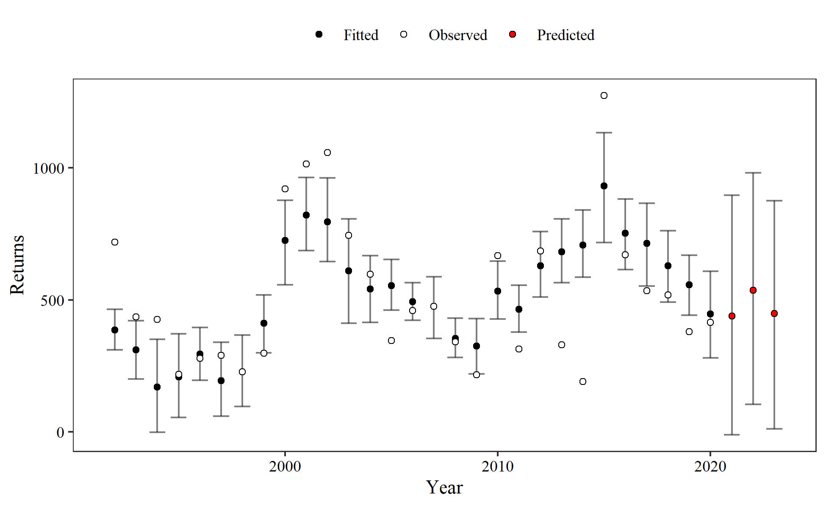

### HOR Winter Steelhead

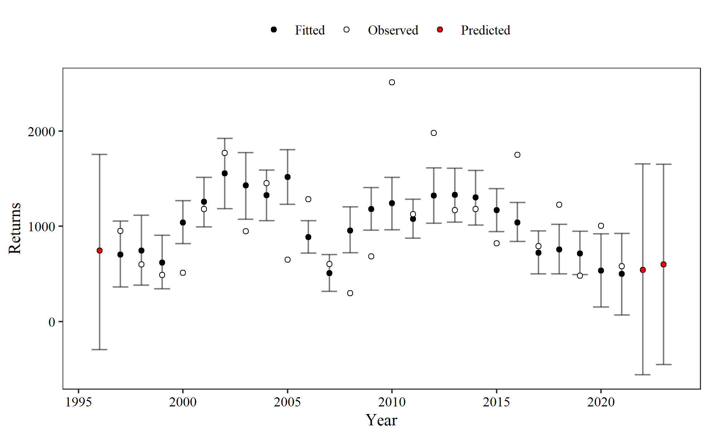

### NOR Summer Steelhead

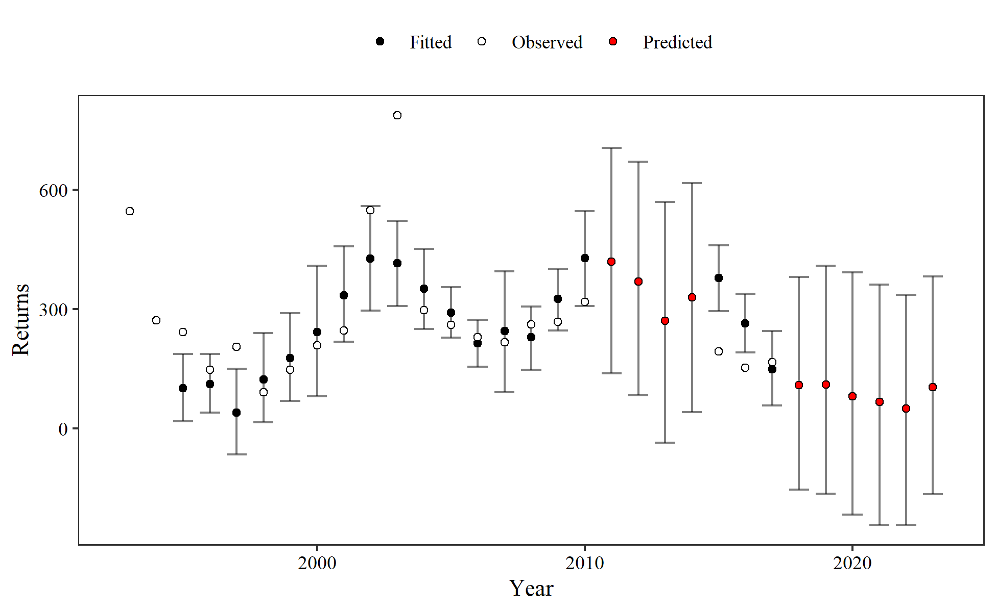

### NOR Spring Chinook

Jack model:

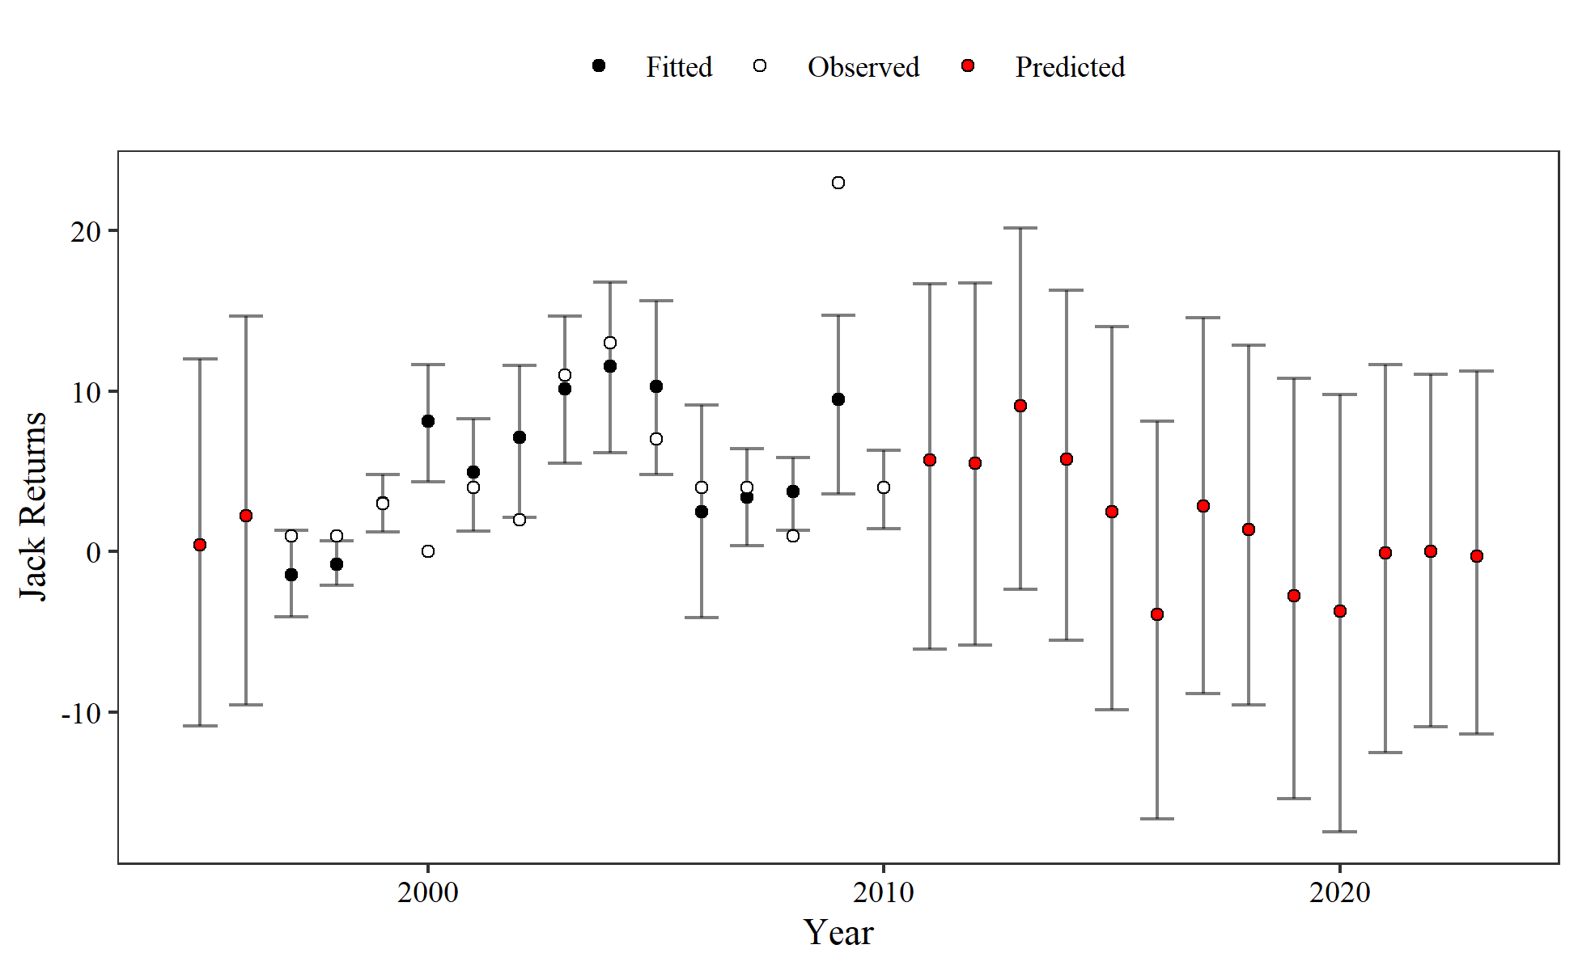

Adult model:

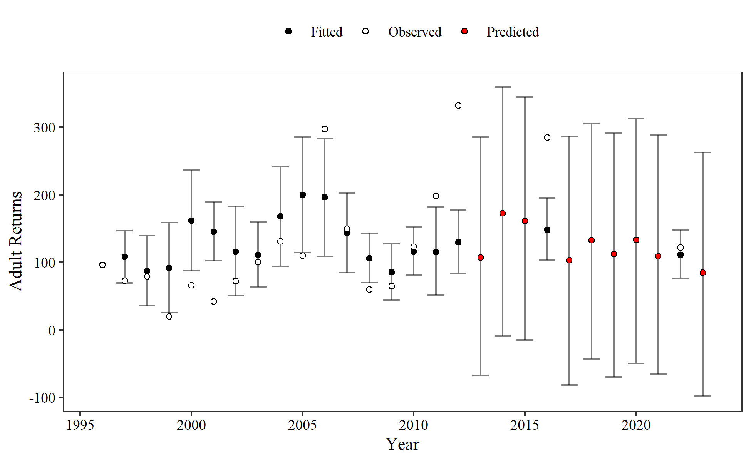

### HOR Spring Chinook

Jack model:

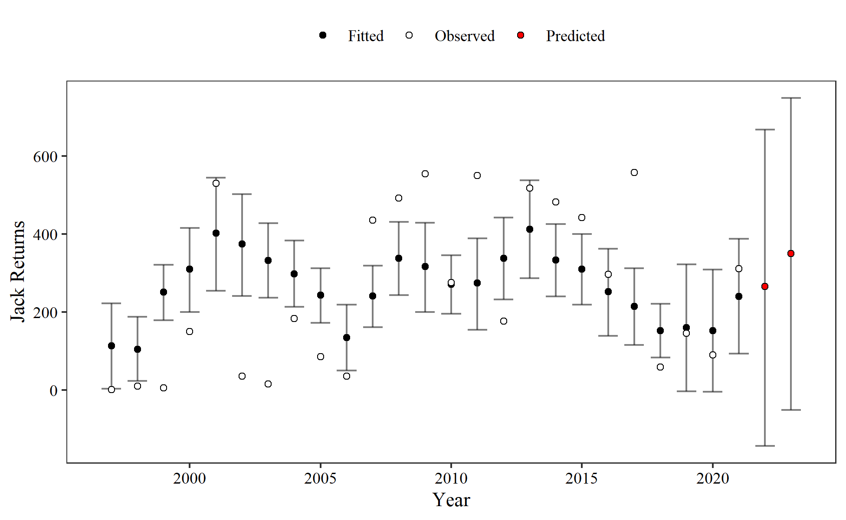

Adult model:

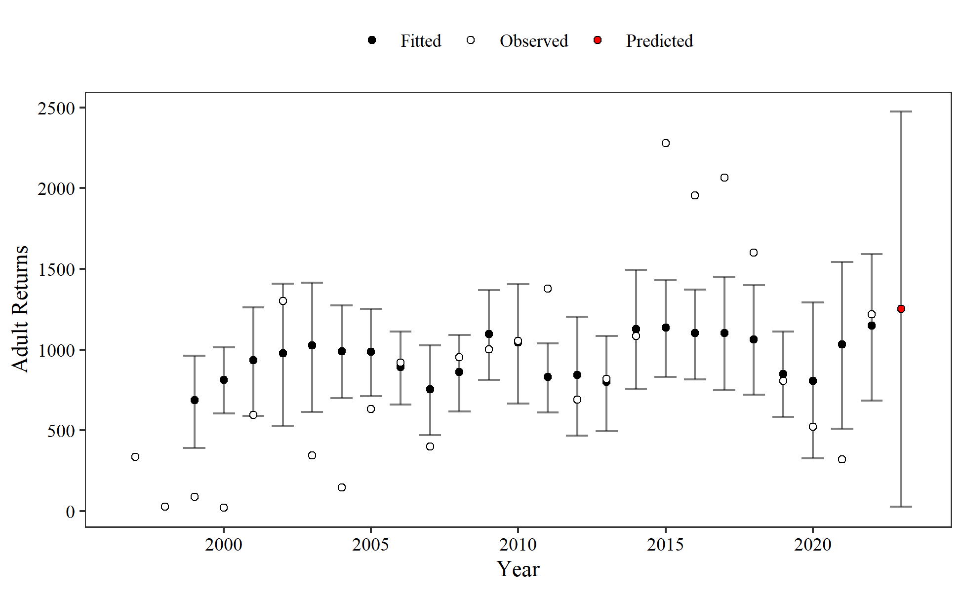

## Model Information

### NOR Winter Steelhead

## Family: gaussian   
## Links: mu = identity; sigma = identity   
## Formula: nor_wsthd_returns ~ 0 + smolt_adj + min_flow_adj + npgo_adj   
## Data: wst_dat (Number of observations: 29)   
## Draws: 4 chains, each with iter = 2000; warmup = 1000; thin = 1;  
## total post-warmup draws = 4000  
##   
## Population-Level Effects:   
## Estimate Est.Error l-95% CI u-95% CI Rhat Bulk_ESS Tail_ESS  
## smolt_adj 0.02 0.01 0.01 0.03 1.00 1963 2005  
## min_flow_adj 17.28 8.06 1.37 33.13 1.00 1996 2216  
## npgo_adj 81.08 36.43 9.02 154.82 1.00 2557 2195  
##   
## Family Specific Parameters:   
## Estimate Est.Error l-95% CI u-95% CI Rhat Bulk_ESS Tail_ESS  
## sigma 210.51 30.21 161.64 277.41 1.00 2200 2217  
##   
## Draws were sampled using sampling(NUTS). For each parameter, Bulk_ESS  
## and Tail_ESS are effective sample size measures, and Rhat is the potential  
## scale reduction factor on split chains (at convergence, Rhat = 1).

### HOR Winter Steelhead

## Family: gaussian   
## Links: mu = identity; sigma = identity   
## Formula: hor_wsthd ~ 0 + smolt_adj + npgo_adj   
## Data: hwst_dat (Number of observations: 25)   
## Draws: 4 chains, each with iter = 2000; warmup = 1000; thin = 1;  
## total post-warmup draws = 4000  
##   
## Population-Level Effects:   
## Estimate Est.Error l-95% CI u-95% CI Rhat Bulk_ESS Tail_ESS  
## smolt_adj 0.02 0.00 0.01 0.02 1.00 3917 2966  
## npgo_adj 244.98 87.60 70.06 415.93 1.00 2167 1975  
##   
## Family Specific Parameters:   
## Estimate Est.Error l-95% CI u-95% CI Rhat Bulk_ESS Tail_ESS  
## sigma 504.20 74.99 382.93 668.36 1.00 2058 2214  
##   
## Draws were sampled using sampling(NUTS). For each parameter, Bulk_ESS  
## and Tail_ESS are effective sample size measures, and Rhat is the potential  
## scale reduction factor on split chains (at convergence, Rhat = 1).

### NOR Summer Steelhead

## Family: gaussian   
## Links: mu = identity; sigma = identity   
## Formula: ssthd ~ 0 + damcount_adj + npgo_adj + min_flow_adj   
## Data: sst_dat (Number of observations: 19)   
## Draws: 4 chains, each with iter = 2000; warmup = 1000; thin = 1;  
## total post-warmup draws = 4000  
##   
## Population-Level Effects:   
## Estimate Est.Error l-95% CI u-95% CI Rhat Bulk_ESS Tail_ESS  
## damcount_adj 0.01 0.00 0.00 0.01 1.00 1557 1920  
## npgo_adj 44.66 35.88 -26.32 112.49 1.00 1961 1705  
## min_flow_adj 0.30 0.33 -0.33 0.95 1.00 1620 1781  
##   
## Family Specific Parameters:   
## Estimate Est.Error l-95% CI u-95% CI Rhat Bulk_ESS Tail_ESS  
## sigma 131.67 23.19 95.69 185.27 1.00 2155 2145  
##   
## Draws were sampled using sampling(NUTS). For each parameter, Bulk_ESS  
## and Tail_ESS are effective sample size measures, and Rhat is the potential  
## scale reduction factor on split chains (at convergence, Rhat = 1).

### NOR Spring Chinook

Jack model:

## Family: gaussian   
## Links: mu = identity; sigma = identity   
## Formula: nor_spch_jack ~ 0 + spch_dam_jack_adj + npgo_jack_adj   
## Data: nsc_dat (Number of observations: 14)   
## Draws: 4 chains, each with iter = 2000; warmup = 1000; thin = 1;  
## total post-warmup draws = 4000  
##   
## Population-Level Effects:   
## Estimate Est.Error l-95% CI u-95% CI Rhat Bulk_ESS  
## spch_dam_jack_adj 0.00 0.00 0.00 0.00 1.00 3165  
## npgo_jack_adj 2.57 1.36 -0.15 5.10 1.00 1085  
## Tail_ESS  
## spch_dam_jack_adj 2637  
## npgo_jack_adj 1033  
##   
## Family Specific Parameters:   
## Estimate Est.Error l-95% CI u-95% CI Rhat Bulk_ESS Tail_ESS  
## sigma 5.39 1.12 3.67 8.00 1.00 1197 1280  
##   
## Draws were sampled using sampling(NUTS). For each parameter, Bulk_ESS  
## and Tail_ESS are effective sample size measures, and Rhat is the potential  
## scale reduction factor on split chains (at convergence, Rhat = 1).

Adult model:

## Family: gaussian   
## Links: mu = identity; sigma = identity   
## Formula: nor_spch ~ 0 + spch_dam_adj + min_flow_adj   
## Data: nsc_dat (Number of observations: 18)   
## Draws: 4 chains, each with iter = 2000; warmup = 1000; thin = 1;  
## total post-warmup draws = 4000  
##   
## Population-Level Effects:   
## Estimate Est.Error l-95% CI u-95% CI Rhat Bulk_ESS Tail_ESS  
## spch_dam_adj 0.00 0.00 0.00 0.00 1.00 2220 2192  
## min_flow_adj 0.30 0.13 0.05 0.56 1.01 1578 1246  
##   
## Family Specific Parameters:   
## Estimate Est.Error l-95% CI u-95% CI Rhat Bulk_ESS Tail_ESS  
## sigma 86.93 15.91 62.00 124.02 1.00 1249 1300  
##   
## Draws were sampled using sampling(NUTS). For each parameter, Bulk_ESS  
## and Tail_ESS are effective sample size measures, and Rhat is the potential  
## scale reduction factor on split chains (at convergence, Rhat = 1).

### HOR Spring Chinook

Jack model:

## Family: gaussian   
## Links: mu = identity; sigma = identity   
## Formula: hor_spch_jack ~ 0 + smolt_jack_adj + npgo_jack_adj   
## Data: hsc_dat (Number of observations: 25)   
## Draws: 4 chains, each with iter = 4000; warmup = 2000; thin = 1;  
## total post-warmup draws = 8000  
##   
## Population-Level Effects:   
## Estimate Est.Error l-95% CI u-95% CI Rhat Bulk_ESS Tail_ESS  
## smolt_jack_adj 0.00 0.00 0.00 0.00 1.00 8058 5661  
## npgo_jack_adj 82.05 31.38 20.36 141.71 1.00 1627 1677  
##   
## Family Specific Parameters:   
## Estimate Est.Error l-95% CI u-95% CI Rhat Bulk_ESS Tail_ESS  
## sigma 193.09 29.98 146.20 257.85 1.00 3071 3271  
##   
## Draws were sampled using sampling(NUTS). For each parameter, Bulk_ESS  
## and Tail_ESS are effective sample size measures, and Rhat is the potential  
## scale reduction factor on split chains (at convergence, Rhat = 1).

Adult model:

## Family: gaussian   
## Links: mu = identity; sigma = identity   
## Formula: hor_spch ~ 0 + smolt_ad_adj_tot + npgo_ad_adj_tot   
## Data: hsc_dat (Number of observations: 24)   
## Draws: 4 chains, each with iter = 2000; warmup = 1000; thin = 1;  
## total post-warmup draws = 4000  
##   
## Population-Level Effects:   
## Estimate Est.Error l-95% CI u-95% CI Rhat Bulk_ESS  
## smolt_ad_adj_tot 0.21 0.03 0.16 0.27 1.00 2940  
## npgo_ad_adj_tot 91.72 97.57 -100.36 278.32 1.00 3115  
## Tail_ESS  
## smolt_ad_adj_tot 2308  
## npgo_ad_adj_tot 2760  
##   
## Family Specific Parameters:   
## Estimate Est.Error l-95% CI u-95% CI Rhat Bulk_ESS Tail_ESS  
## sigma 577.82 92.20 431.28 794.35 1.00 3295 2555  
##   
## Draws were sampled using sampling(NUTS). For each parameter, Bulk_ESS  
## and Tail_ESS are effective sample size measures, and Rhat is the potential  
## scale reduction factor on split chains (at convergence, Rhat = 1).